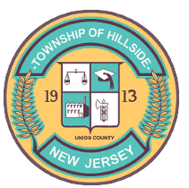
DAHLIA O. VERTREESE TOWNSHIP OF HILLSIDE ARTHUR KOBITZ
MAYOR DEPARTMENT OF PUBLIC WORKS ACTING DIRECTOR
274 HILLSIDE AVENUE
HILLSIDE, NJ 07205
(973) 926-1110
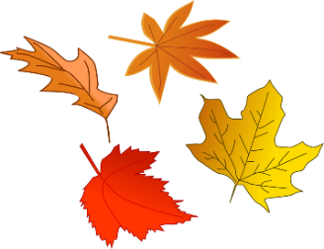
NOTICE TO TOWNSHIP OF HILLSIDE RESIDENTS
LEAF SEASON
The 2021 leaf collection from the roadway gutter area will commence on November 1st,2021 and continue through December 17th, 2021. Residents are asked at that time to rake leaves into the street 4”-6” from the curb to allow for drainage. Crews will pick up the leaves on scheduled street cleaning days depending on weather conditions. Piles of leaves will not be picked up if they contain branches, grass, brush, stones, or garbage.
IF YOU HAVE ANY ADDITIONAL LEAVES, BAG THEM FOR DISPOSAL ON YOUR SECOND GARBAGE DAY (COLLECTION DAY ONLY) AS ONE OF YOUR THREE (3) PIECES OF BULK.
VEGETATIVE WASTE
ORDINANCE 261-6 & 261-16
Vegetative waste includes grass, branches and leaves.
Tree branch bundles should meet the following criteria to be placed at the curb for bulk pick up:
- Weigh no more than fifty (50) pounds,
- Maximum four (4) feet in length, and
- Each branch should be ten (10) inches or less in diameter (includes trucks and stumps)

All other vegetative waste must be placed in biodegradable paper bags when placed at the curb for bulk pick up. Free leaf bags provided by Department of Public Works.

