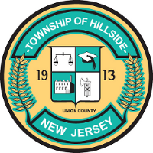

FEMA
Disaster Survivor Assistance (DSA)Teams

DSA Mission Essential Tasks:
Assess, Inform and Report (AIR), Registration Intake, Survivor Case Updates/Inquiries,
FEMA Disaster Survivor Assistance teams will be in the Hillside Township area beginning Tuesday, Oct 5, 2021.
The DSA teams will be canvasing/walking through impacted neighborhoods, distributing informational flyers, and helping survivors in the following ways:

- Assisting survivors to register for FEMA assistance.
- Checking the status of an application already in the system and can make minor changes to applications.
- Making calls to faith-based organizations, community-based organizations, private sector (businesses) and public libraries that may have the capability to distribute disaster-related information to survivors in the impacted counties.
Information provided by the teams are tailored to the individual survivor’s needs and may include information on making temporary repairs to a disaster-damaged house, pay for another short-term place to live while permanent repairs are made and/or help with serious, disaster-related needs not covered by other programs.
DSA teams can easily be identified by their federal photo identification and FEMA clothing. New Jersey residents are reminded to ask for official photo identification before sharing personal information.
The teams are following CDC safety guidelines for COVID-19 including social distancing and use of protective equipment.

